https://www.youtube.com/?hl=es&gl=E

Classroom Drive Gmail
https://edu.google.com/intl/es-419/products/productivity-tools/classroom/
https://www.google.es/drive/apps.html
https://www.google.com/gmail/

EUSTAT http://www.eustat.eus/indice.html
INE www.ine.es/
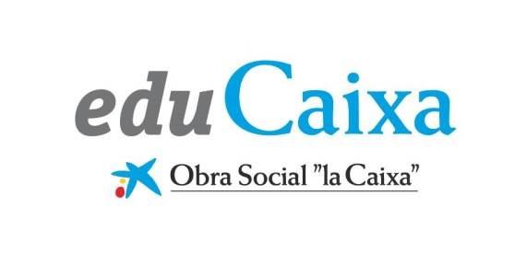 https://www.educaixa.com/

https://www.mheducation.es

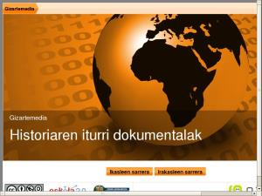 Baliabide orokorrak
http://historiarakobaliabideak.wikispaces.com/BALIABIDE+OROKORRAK

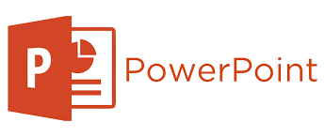 https://play.google.com/store/apps/details?id=com.microsoft.office.powerpoint&hl=es

