GEOGRAFIA –HISTORIA MINTEGIA
https://www.youtube.com/?hl=es&gl=E

Classroom Drive Gmail
https://edu.google.com/intl/es-419/products/productivity-tools/classroom/
https://www.google.es/drive/apps.html
https://www.google.com/gmail/

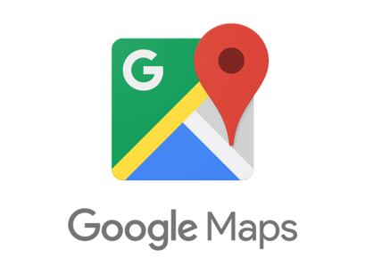https://www.google.es/maps

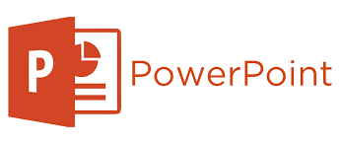https://play.google.com/store/apps/details?id=com.microsoft.office.powerpoint&hl=es

EUSTAT http://www.eustat.eus/indice.html
INE www.ine.es/
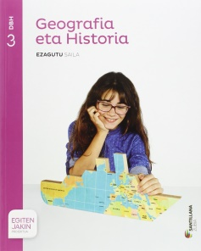 www.digital.santillana.es 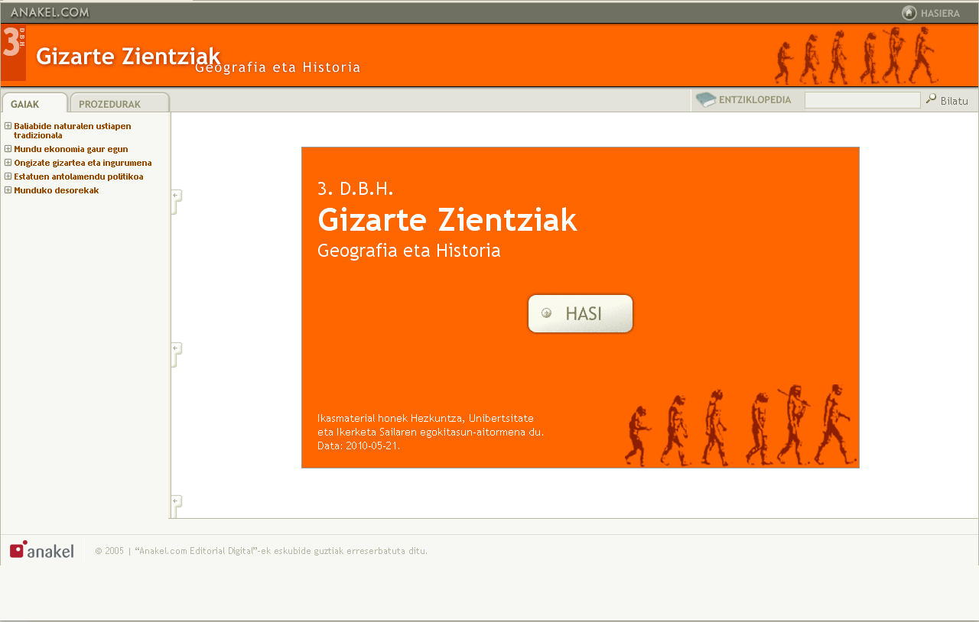 www.anakel.com/
https://www.educaixa.com/
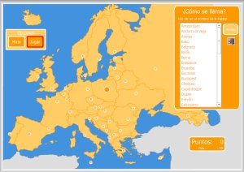 Mapa Interaktiboak
https://mapasinteractivos.didactalia.net/comunidad/mapasflashinteractivo
http://serbal.pntic.mec.es/ealg0027/mapasflash.htm
https://www.mheducation.es

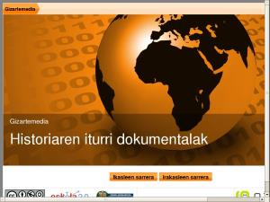 Baliabide orokorrak
http://historiarakobaliabideak.wikispaces.com/BALIABIDE+OROKORRAK

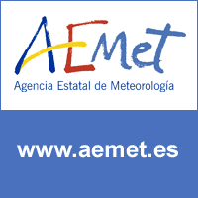
www.euskadi.eus/meteo/ www.aemet.es/es/portada

