**Gorputz Hezkuntzan erabiltzen ditugun baliabide digitalak**

Sudurgorri orrialdea:

[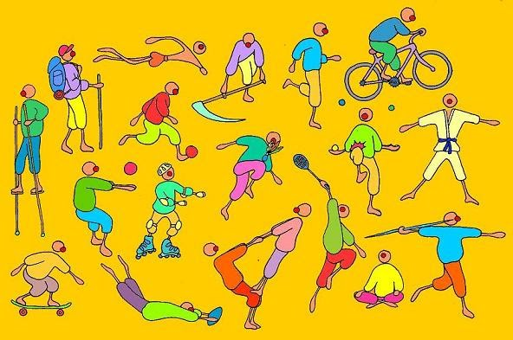](https://sites.google.com/site/sudurgorribi/)

Recursos MEC:

[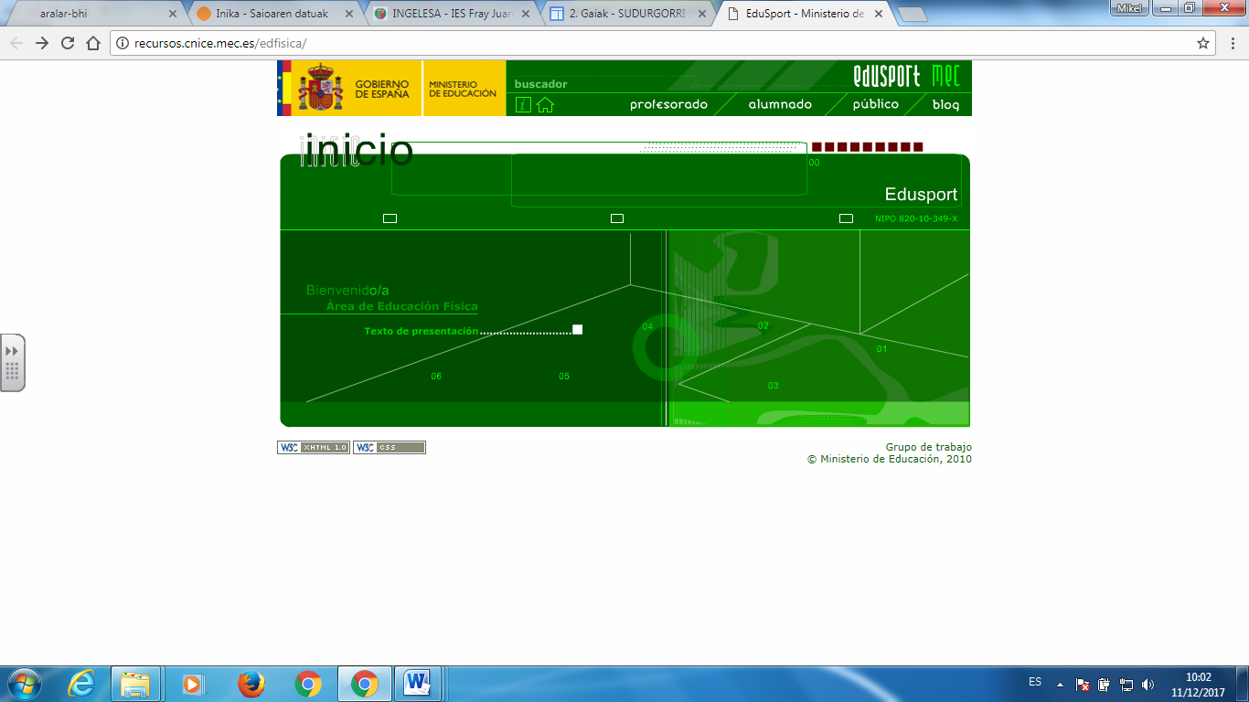](http://recursos.cnice.mec.es/edfisica/)

Gorputz Heziketa.net:

[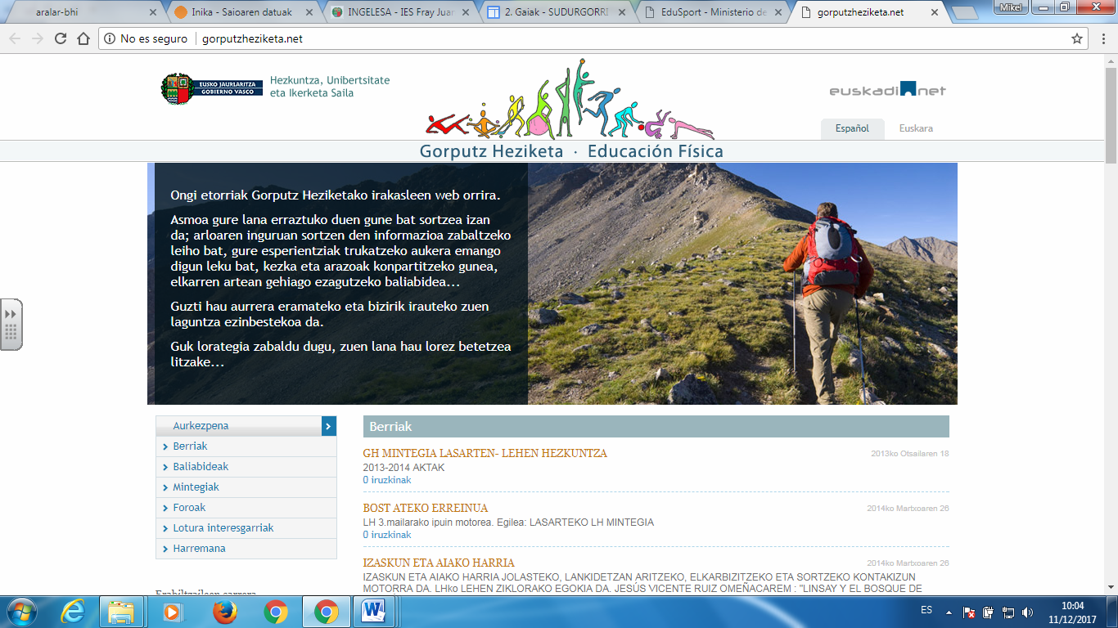](http://gorputzheziketa.net)

Gure Osasuna hobetu dezagun site-a:

[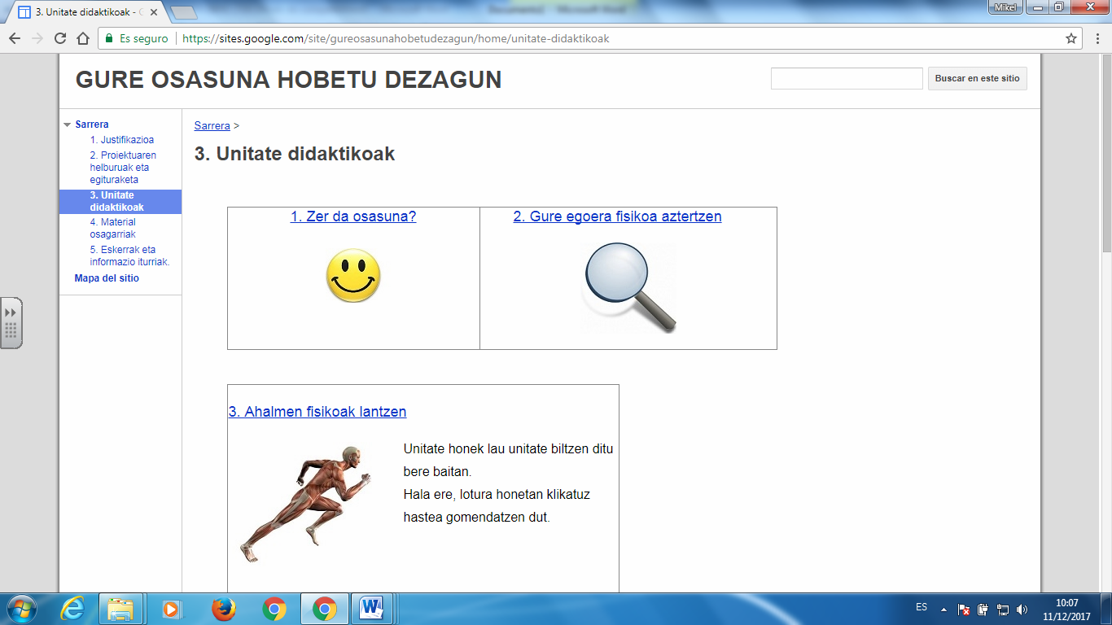](https://sites.google.com/site/gureosasunahobetudezagun/)

Gorputz Heziketako irakasleen webgunea:

[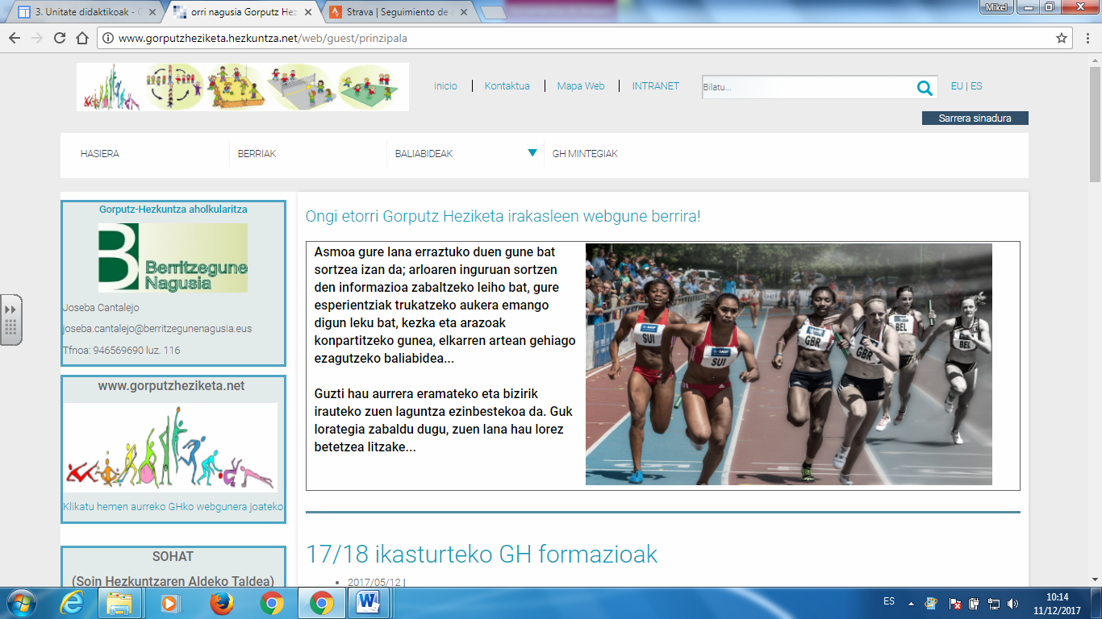](http://www.gorputzheziketa.hezkuntza.net/web/guest/prinzipala)

**Gorputz Heziketan erabiltzen ditugun aplikazio digitalak.**

[](https://www.strava.com/)

[](http://www.oruxmaps.com/cs/es)

[](mailto:https://www.google.es/maps/@43.1071269,-2.0959439,15z?hl=eu)

[](https://www.google.es/intl/es/earth/index.html)

[](mailto:https://eu.wikiloc.com/)

[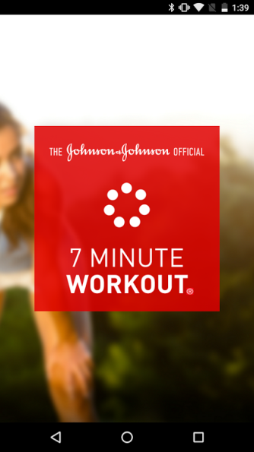](mailto:https://7minuteworkout.jnj.com/)

[](https://edu.google.com/intl/es-419/products/productivity-tools/classroom/)

[](https://www.youtube.com)